**Создание работника и пользователя к нему**

CREATE OR REPLACE PROCEDURE CreateWorkerWithUser(

IN last_name VARCHAR(70),

IN first_name VARCHAR(70),

IN patronymic VARCHAR(70),

IN birth_date DATE,

IN passport_series VARCHAR(4),

IN passport_number VARCHAR(6),

IN address TEXT,

IN phone_number VARCHAR(16),

IN positionid INT,

IN login VARCHAR(50),

IN password VARCHAR(100)

)

LANGUAGE plpgsql

AS $$

DECLARE

user_id INT;

BEGIN

INSERT INTO users (login, password)

VALUES (login, password)

RETURNING userid INTO user_id;

INSERT INTO workers (last_name, first_name, patronymic, birth_date, passport_series, passport_number, address, phone_number, positionid, userid)

VALUES (last_name, first_name, patronymic, birth_date, passport_series, passport_number, address, phone_number, positionid, user_id);

END;

$$;

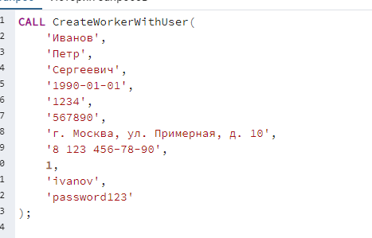



**Удаление работника**

CREATE PROCEDURE DeleteWorker(

IN Worker_ID INT

)

AS $$

BEGIN

DELETE FROM workers WHERE workers.workerid = Worker_ID;

END

$$ LANGUAGE plpgsql; 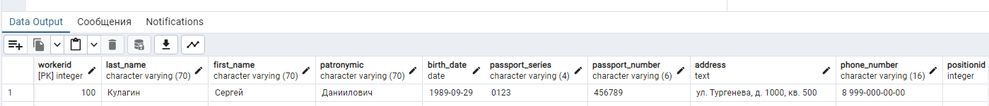

**Изменение данных сотрудника**CREATE OR REPLACE PROCEDURE UpdateWorkerInfo(

IN worker_id INT,

IN new_last_name VARCHAR(70),

IN new_first_name VARCHAR(70),

IN new_patronymic VARCHAR(70),

IN new_birth_date DATE,

IN new_passport_series VARCHAR(4),

IN new_passport_number VARCHAR(6),

IN new_address TEXT,

IN new_phone_number VARCHAR(16),

IN new_position_id INT,

IN new_user_id INT

)

LANGUAGE plpgsql

AS $$

BEGIN

UPDATE workers

SET

last_name = new_last_name,

first_name = new_first_name,

patronymic = new_patronymic,

birth_date = new_birth_date,

passport_series = new_passport_series,

passport_number = new_passport_number,

address = new_address,

phone_number = new_phone_number,

positionid = new_position_id,

userid = new_user_id

WHERE

workerid = worker_id;

END;

$$; 